Part1:

Dataset Used:

P1-PersonalVehicleSalesGlobal.xlsx

Visualization Process:

1. Cleaned the dataset

1. A. Created a stacked bar to show number of vehicle sale (in million) per year

B. Showing the dataset in terms of percentage. It gives a clear view of what percentage of data was sold in what continents.

1. Vehicle sold by country.

Part 2:

Dataset Used:

P1-StartupExpansion.xlsx

Visualization:

Follow the process.

1. Showing two reasons.

1. It shows revenue per region, Average Sales per region, Average marketing spend, Average Revenue.

1. Created a highlighter to show new and old expansion of startups. Highlighted are new.
2. Showing New Expansion.

1. Showing Old Startup

1. Created a cluster for both regions.
2. New expansion in a cluster.

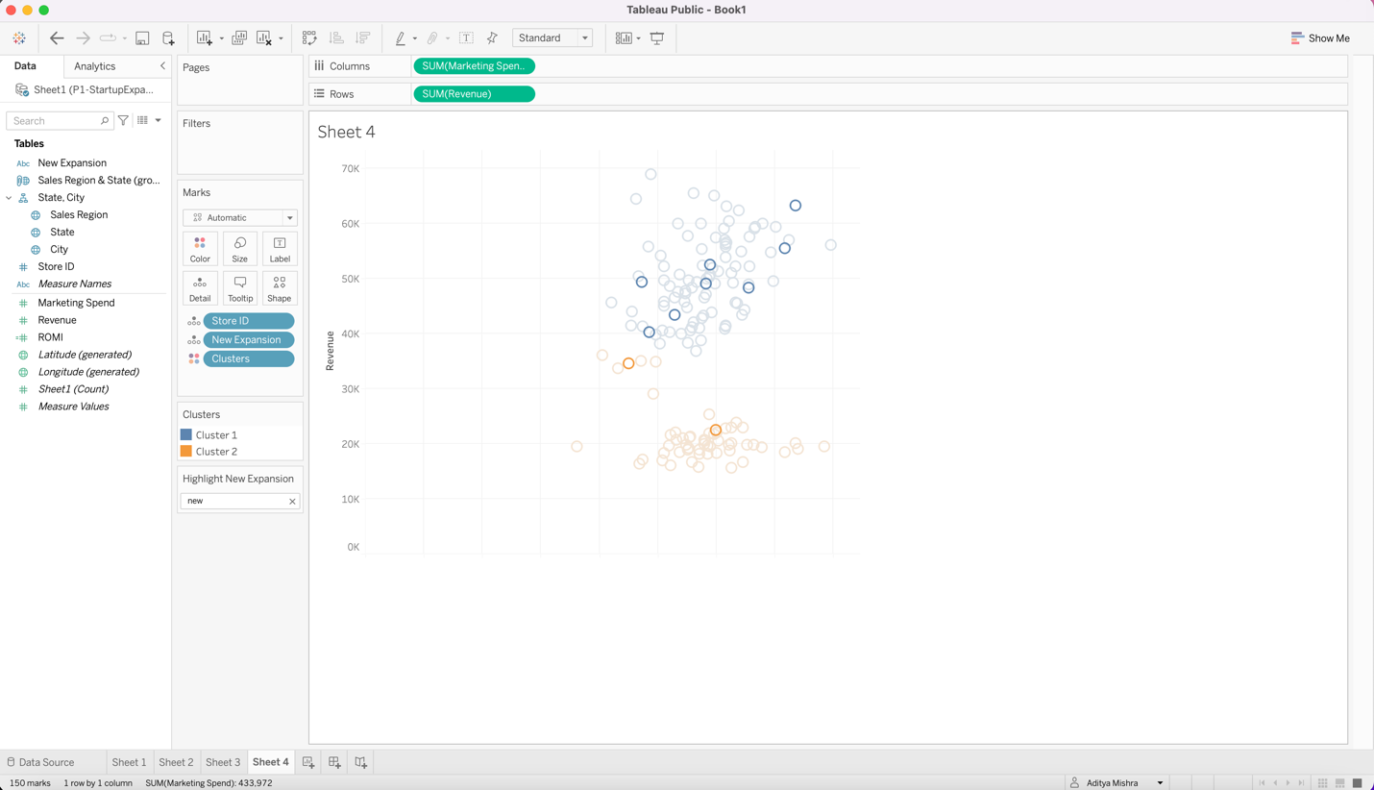

1. Cluster of old expansion.

1. Attached a Trend Line to analyze the expansion. Found the slope of all three cluster.
2. Old branches.

1. New Expansion.

1. As per our analysis, our highest slope is for the expansion in the blue range which means this expansion will give the most revenue per dollar.

1. Created a dashboard for the expansion which includes both map and our clustering.

1. After analyzing the company data, we can determine that if the company wants to invest more in 4 branches and get maximum return then they should invest in the blue region which falls in California, Illinois and New jersey. The exact location of their respective city is shown in the picture.

